LED BLINKING CIRCUIT

PRESENTED BY:- Aman kumar

CS(IOT)

OBJECTIVE: TO DEMONSTRATE THE PRINCIPLES OF BASIC

ELECTRONICS, PARTICULARLY USE OF 7805 IC OR MICROCONTROLLER TO CONTROL ON /OFF CYCLE OF LED.

* Understanding Basic Circuitry:
* The project introduces fundamental concepts like resistors, capacitors, LEDs, and transistors (if used).
* Learning about Timing Circuits(Ex. Traffic light system):
* A key aspect is understanding how the microcontroller generates the timing signals that control the LED’s blinking frequency.

COMPONENTS USED :

❖Essential Components:

❖LED (Light Emitting Diode): The component that produces light when current flows through it.

❖Resistor: Limits the current flowing through the LED, preventing it from burning out.

❖Power Source: Provides the electrical energy to operate the circuit (e.g., battery). ❖Jumper Wires: Connects the components on a breadboard or other prototyping platform.

OPTIONAL COMPONENTS FOR MORE ADVANCED BLINKING CIRCUITS:

* Breadboard:
* A board with conductive pathways for easy circuit assembly and modification.
* 555 Timer IC:
* A versatile integrated circuit that can be used to create various timing circuits, including blinking LEDs.
* Capacitors:
* Used in conjunction with resistors and the 555 timer to control the blinking frequency.
* Transistors:
* Can be used in conjunction with resistors and capacitors to create astable multivibrator circuits for blinking LEDs.
* Resistors (additional):
* Used in various configurations to control current and voltage levels within the circuit.

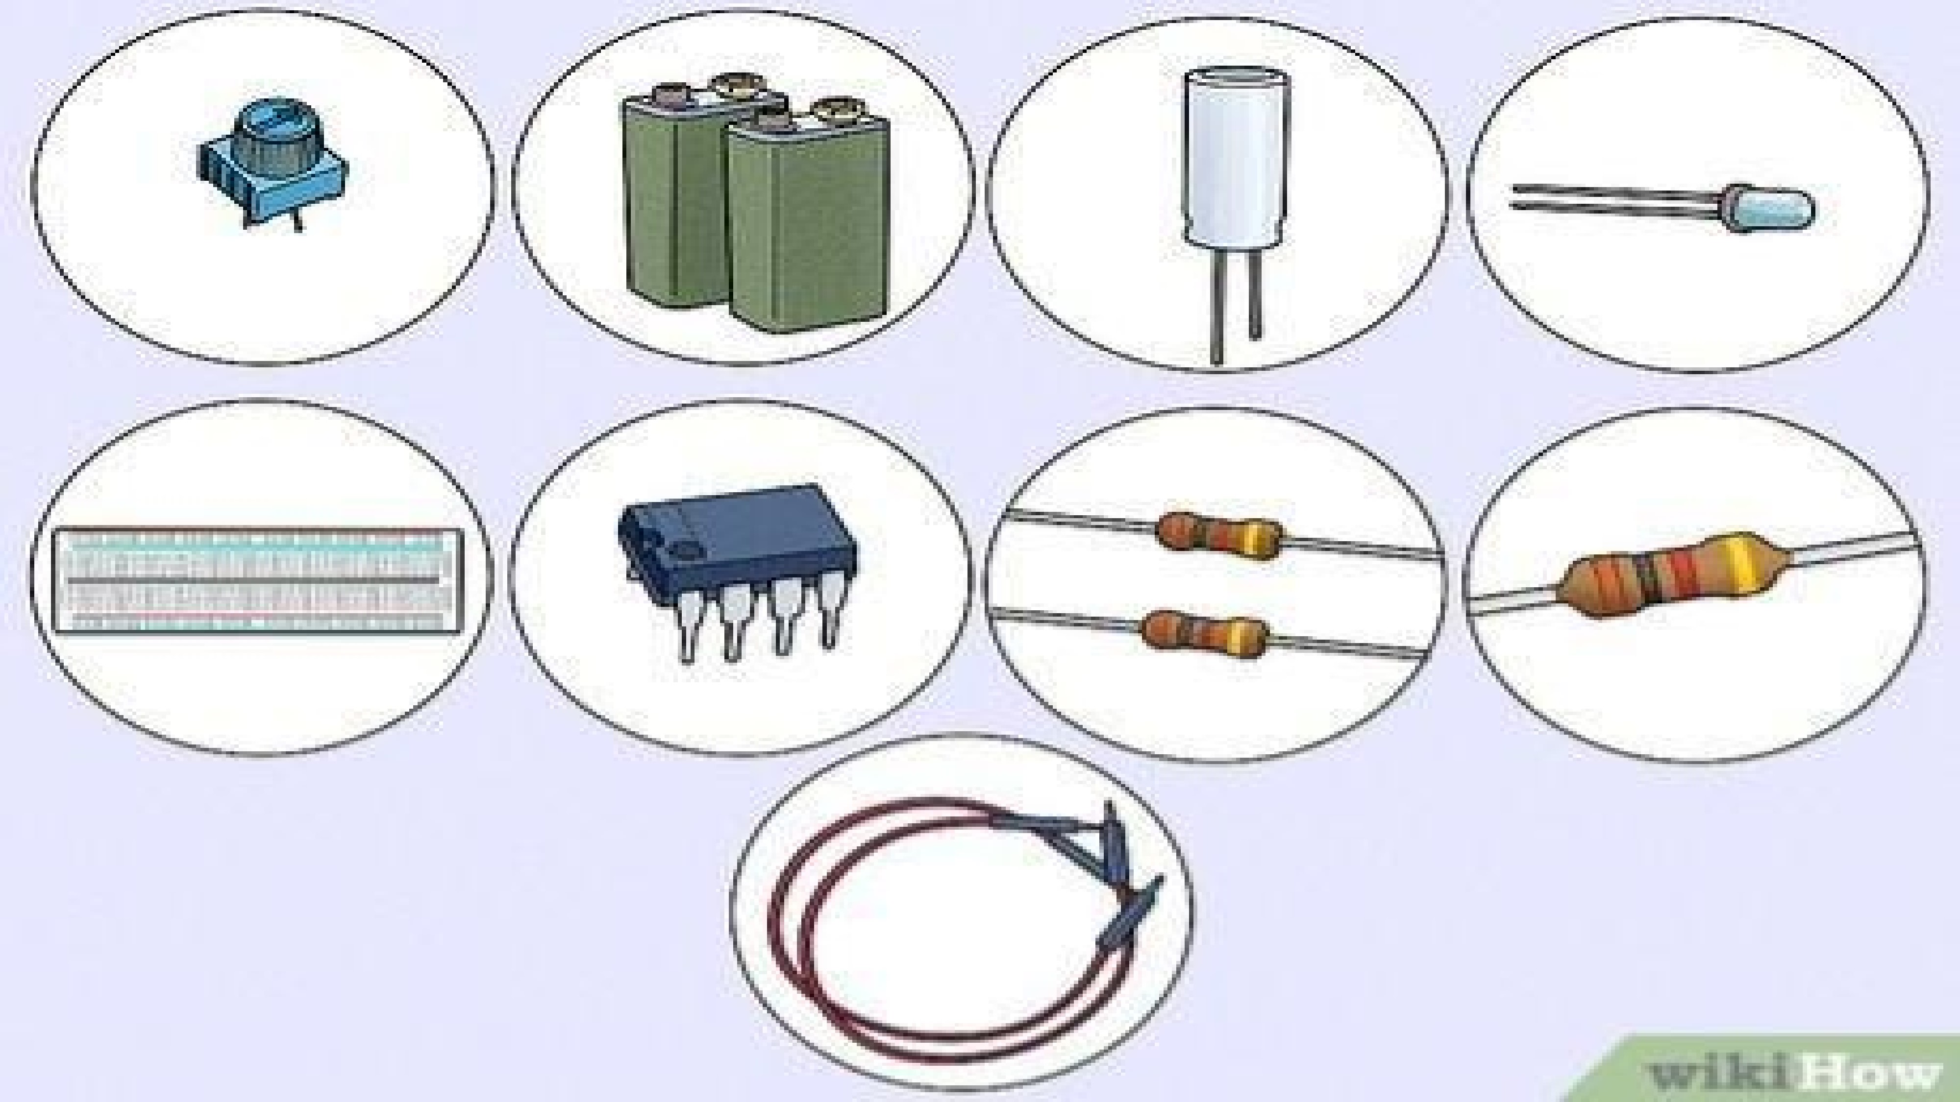

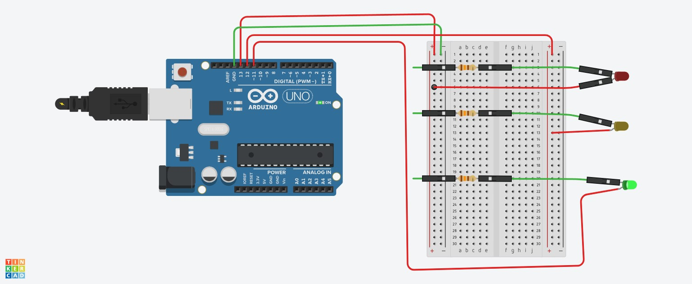CIRCUIT DIAGRAM:

SCHEMATIC DIAGRAM:

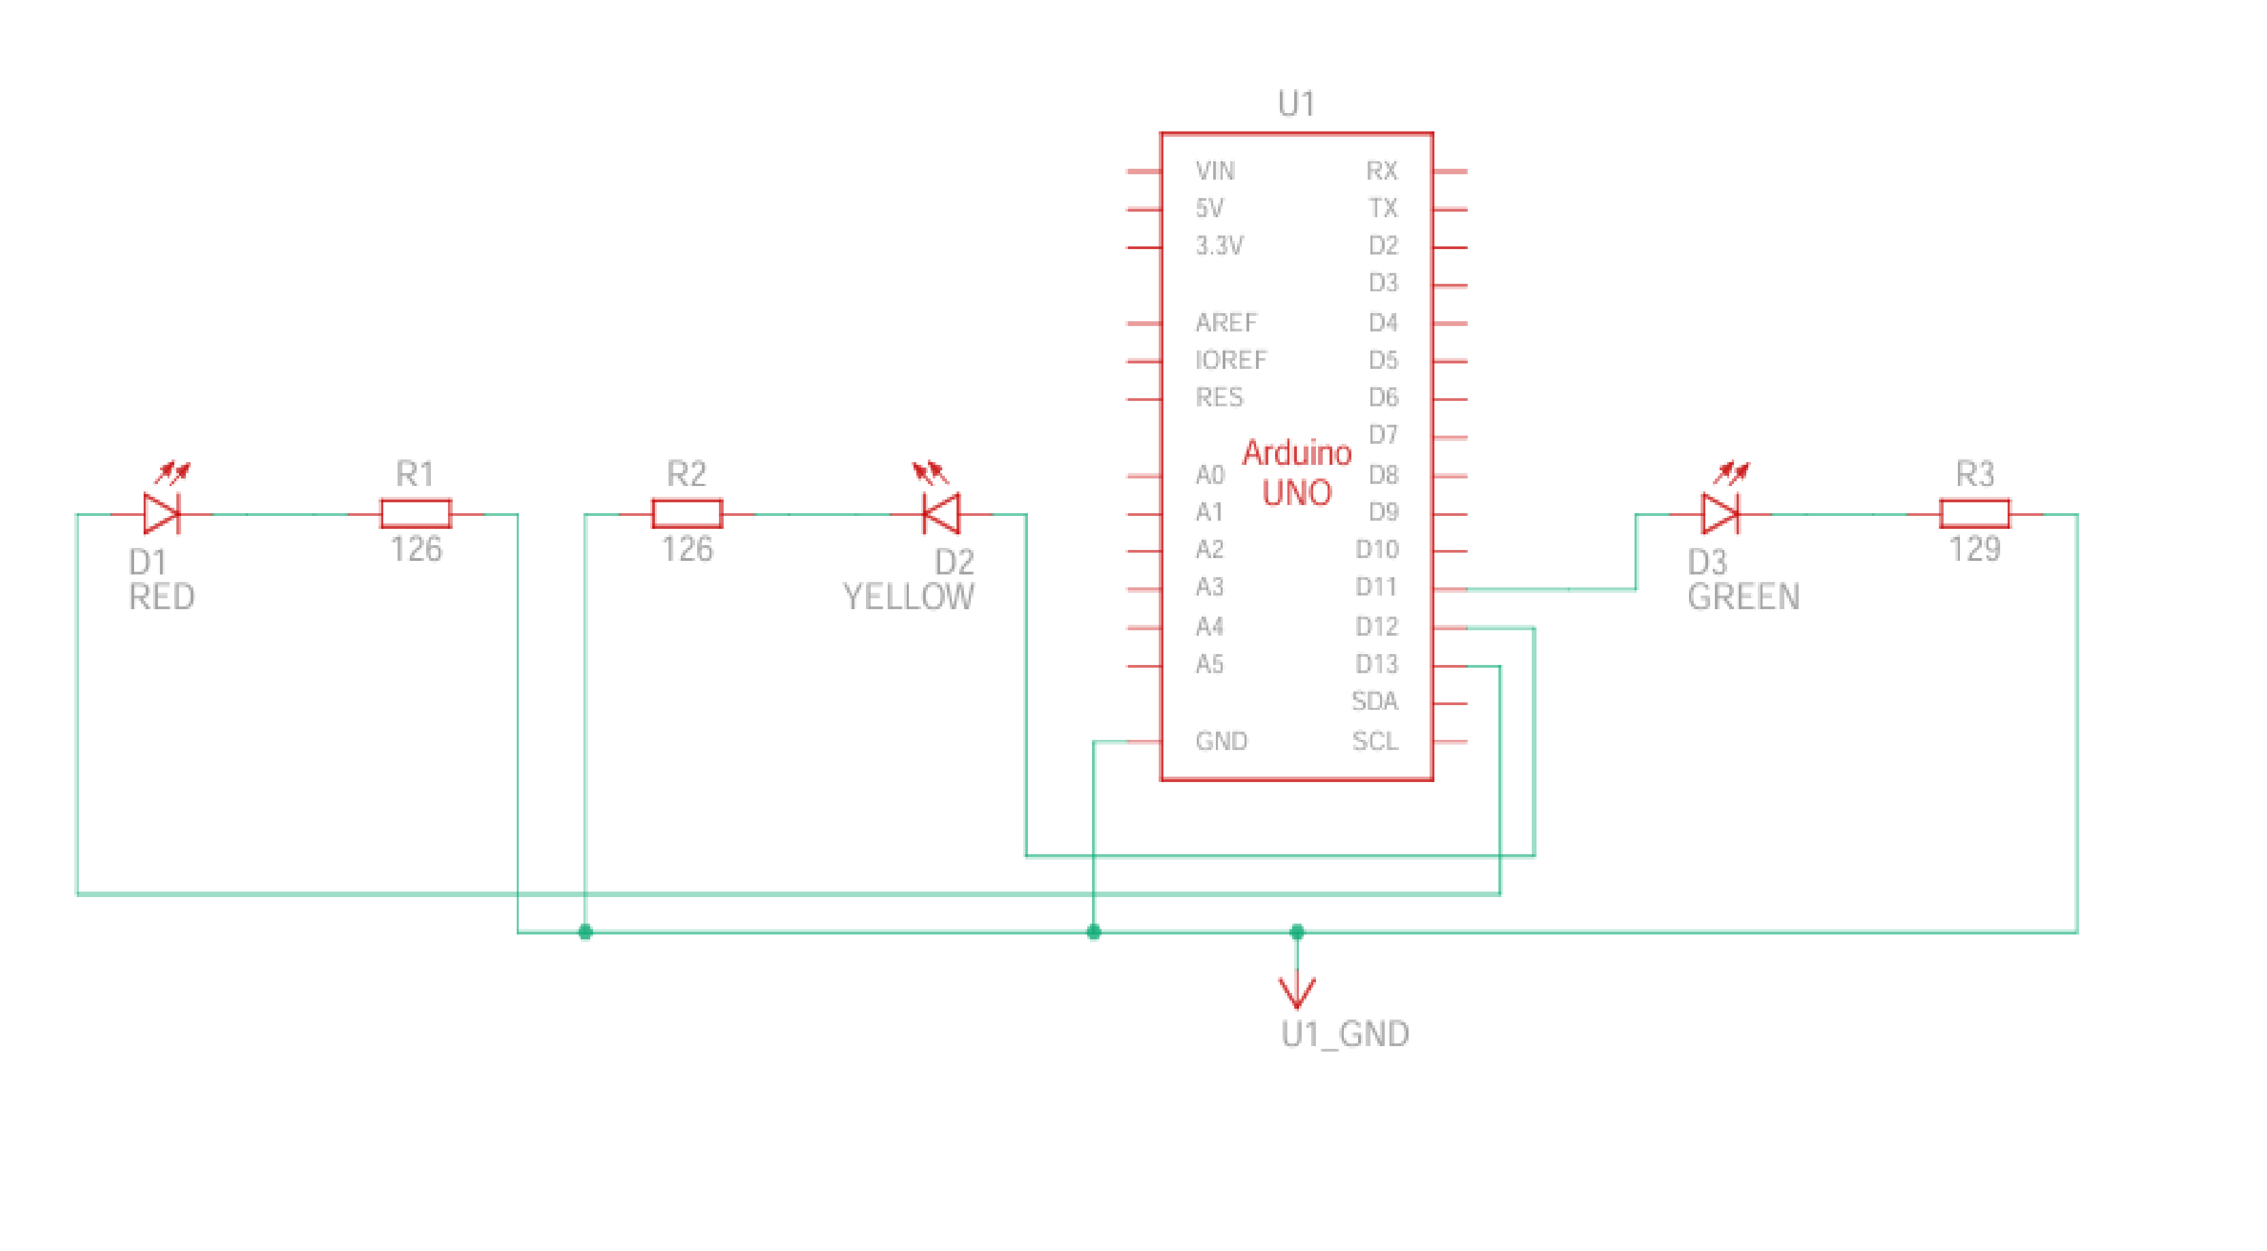

TEXT CODE:

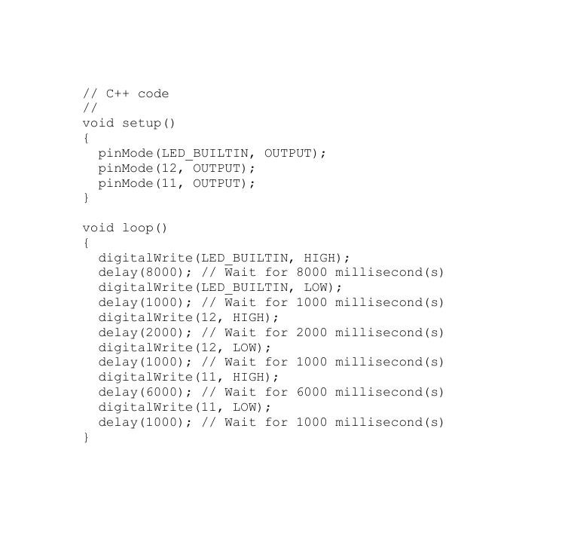

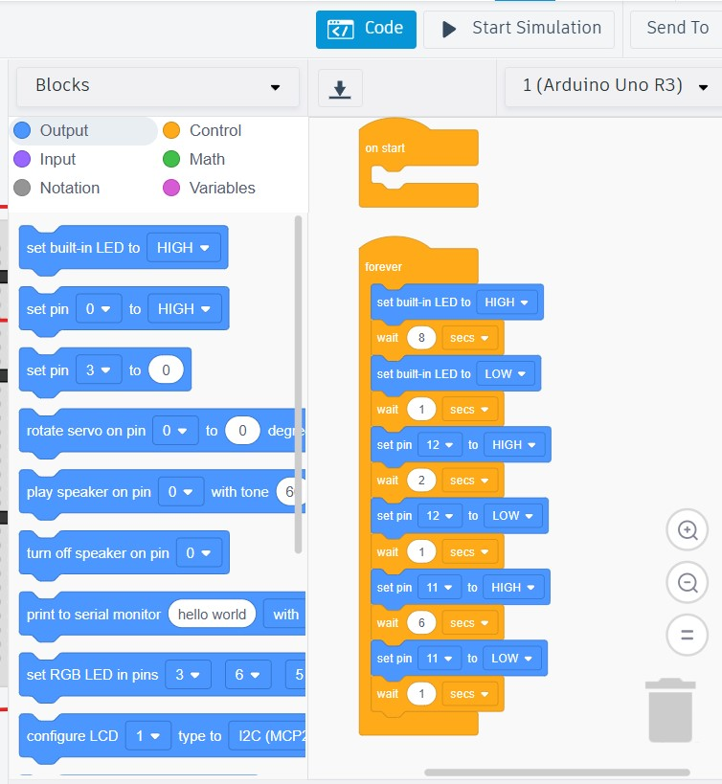BLOCK CODE:

CONCLUSION:

* Component functionality: Understanding how transistors, resistors, capacitors, and diodes work together.
* Circuit analysis: Learning to predict and analyze the behavior of simple circuits.
* Troubleshooting: Developing skills to identify and fix potential issues in the circuit.

